1. Project Title: AI-Powered Smart Irrigation System for Predictive Water Management and Crop Optimization
2. Project Statement and Outcomes:
Farmers consistently overuse or underuse water due to the absence of real-time, data-driven insights, leading to significant water wastage and reduced crop yield. Critically, most existing precision agriculture tools assume desktop access and English literacy, placing them out of reach for the majority of smallholder farmers in India. This project builds a full-stack AI-powered platform that integrates soil moisture sensor feeds, real-time weather forecast APIs, crop type databases, and historical irrigation data to recommend precise, field-specific irrigation schedules. Machine learning models such as Random Forest and LSTM networks, trained on multi-season agricultural datasets, dynamically predict when and how much water each field requires. Recommendations are delivered through a mobile-first Progressive Web App (PWA) built with Next.js. To bridge the language and literacy gap, the platform integrates Sarvam AI — a specialized Indic-language AI service — for real-time voice-based queries and context-aware translation in Hindi, Kannada and going beyond static UI text to make AI-generated irrigation advice genuinely accessible in the farmer’s own language.
The deliverable is a complete end-to-end platform centred on a single farmer-facing Progressive Web App (PWA) built with Next.js — featuring large icons, AI-powered regional language support (Hindi, Kannada) via Sarvam AI, and clear irrigation alerts designed to be operable without English literacy or app store installation. The PWA approach was deliberately chosen over a native Android app to keep the build within the 8-week internship scope: it runs in any Android browser, requires no Play Store approval, and allows faster iteration. By reducing water overuse while improving crop health through data-driven recommendations, the platform will empower farmers to adopt sustainable irrigation practices and achieve measurably improved yield across diverse crop types and geographic regions.
3. Modules to be Implemented:
1. Sensor Data Ingestion & Weather API Integration
2. ML-Based Irrigation Scheduling Engine
3. Mobile-First Farmer PWA (Next.js), Alert & Notification System
4. System Integration, Testing & Project Finalization
4. Week-wise Module Implementation and High-Level Requirements:
Weeks 1–2: Sensor Data Ingestion & Weather API Integration
• Design and implement a data ingestion pipeline for soil moisture sensor feeds and IoT device data using MQTT or REST APIs.
• Integrate third-party weather forecast APIs (OpenWeatherMap, Tomorrow.io) for temperature, rainfall, and humidity data.
• Build a crop type and field configuration module where farmers register their fields, crops, and sensor identifiers.
• Implement data cleaning and normalization routines to handle missing sensor readings and API downtime gracefully.
• Set up a relational database schema (PostgreSQL) and time-series storage (InfluxDB or TimescaleDB) for historical sensor data.
Weeks 3–4: ML-Based Irrigation Scheduling Engine
• Perform feature engineering combining soil moisture, weather forecasts, crop growth stage, and historical water usage patterns.
• Train and evaluate multiple ML models (Random Forest, Gradient Boosting, LSTM) for irrigation volume and schedule prediction.
• Implement a schedule optimizer that converts model outputs into actionable, time-slotted irrigation plans per field.
• Build a FastAPI-based model serving API that provides real-time irrigation recommendations for registered fields.
• Version and track model performance using MLflow to support iterative improvement as new seasonal data arrives.
Weeks 5–6: Mobile-First Farmer PWA (Next.js), Alert & Notification System
• Scaffold a Next.js project configured as a Progressive Web App (PWA) using next-pwa: set up the service worker, web app manifest (name, icons, theme colour).
• Build the farmer-facing mobile view using Next.js responsive components: large tap-friendly buttons, colour-coded field status cards (red/yellow/green for soil moisture), and a Today’s Schedule screen showing irrigation time and duration as icon-driven cards. Implement next-i18next for static UI string translations (button labels, headings) in Hindi and Kannada. In addition, integrate the Sarvam AI API for dynamic content — reading AI-generated irrigation recommendations and sensor alerts aloud in the farmer’s regional language, and optionally accepting voice queries. These two layers are complementary: next-i18next handles fixed UI copy, Sarvam AI handles context-aware language conversion of live data.
• Build supporting farmer screens within the same Next.js app: a field overview page with sensor reading timelines, a weekly irrigation history view, and Chart.js / Recharts visualisations for water usage trends — all rendered as simple colour-coded summaries, not dense analytics grids, keeping the interface accessible for low-literacy users.
• Implement multi-channel alert and notification delivery: Web Push Notifications via the browser Push API (works on Android Chrome without a native app), SMS alerts via Twilio for farmers without reliable internet, and email notifications via SendGrid for supervisors — all with configurable per-field thresholds triggered by the ML alert engine.
• Build a rule-based and ML-driven alert engine that triggers notifications for critical conditions such as drought risk, over-watering, and sensor failure. Implement a downloadable field report generator (PDF/CSV). Deploy the Next.js frontend and FastAPI backend using Docker on a cloud provider with CI/CD pipelines.
Weeks 7–8: System Integration, Testing & Project Finalization
• Conduct end-to-end integration testing across all modules — sensor ingestion → ML scheduler → alert engine → farmer dashboard — and resolve any cross-module compatibility issues and edge-case failures.
• Perform load and stress testing on the backend APIs and cross-browser UI validation; address performance bottlenecks and implement enhancements from peer and mentor review.
• Refine the user experience based on testing feedback: improve interface clarity, add contextual help tooltips, and ensure full responsiveness on mobile and tablet devices. Verify the accuracy of Sarvam AI-generated translations and voice output across irrigation advisory content in Hindi and Kannada, and validate behaviour under low-bandwidth conditions representative of rural connectivity.
• Prepare comprehensive project documentation covering system architecture, data flow diagrams, API reference, model or algorithm evaluation report, deployment guide, and known limitations.
• Develop the final project presentation (PPT) covering problem statement, proposed solution, architecture, key features, technology stack, results, challenges, and future scope — and rehearse the full end-to-end demo for a smooth, confident delivery.
5. Flow Chart:
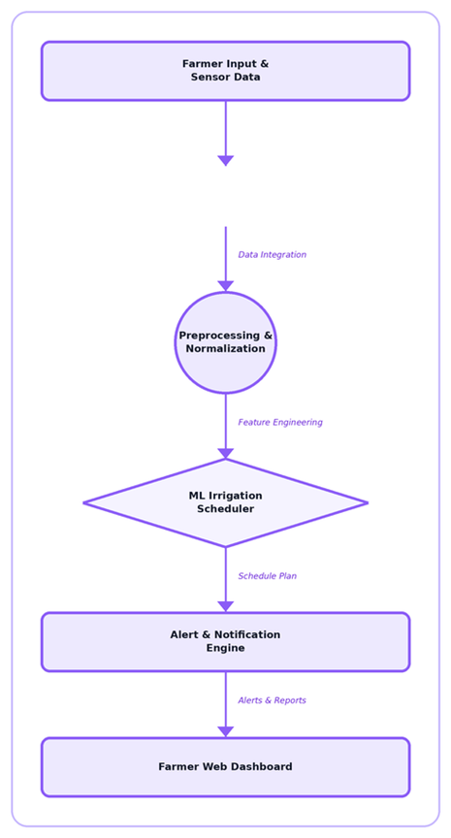
6. Sample Dashboard:

